Mindfulness and Social Justice Workshop
Building community and finding meaning in the helping professions: A morning workshop for clinicians, educators and other helpers.
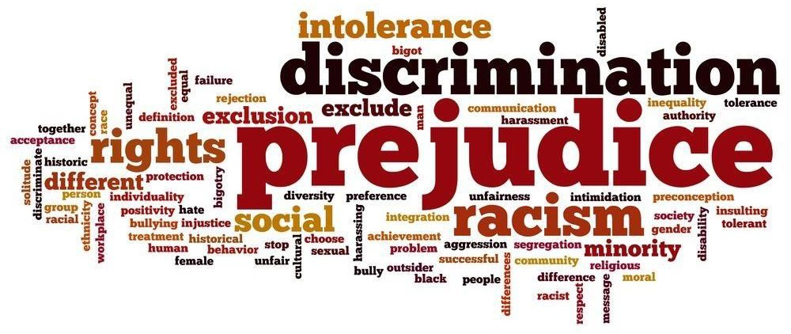
As helping professionals, we meet every day with clients who are frightened by the current climate in our country and the world. Please join us for a mindfulness/discussion session where we reconnect with the values that brought us into our professions, and travel beyond burnout and cynicism. We will support each other in finding our personal commitments to action to foster hope and understanding.

Where: 61 Harvard Street, Worcester When: Monday, July 31st, 2017
Time: 9:30am – 12:30pm Facilitator: Zaza Sakhat, LICSW
Guest speakers.

Continental breakfast will be provided.

$25 per person - Register by July 15th. Space is limited to 8 people.

To register: zazasakhat.eventbrite.com .
Contact zaza@zsakhattherapy.com or 508-579-2964 for more information.

Parking is in the old Worcester Courthouse lot at the corner of Highland and Harvard Street, anywhere alongside the yellow pillars by the building.

